How to Guide for Applying for Customer-Side Shut-Off Valve Rebates
Current City ordinance prohibits anyone other than City staff or plumbing companies authorized by the City, as part of the City’s Small Water Service Access Program, from operating any portion of the water system infrastructure including City-owned shut-off valves located in each residential water service meter box. The Customer-Side Shut-Off Valve Rebate Program was created to give financial incentives to encourage our residential customers to install shut-off valves on the customer side of the water meter (See photo below).
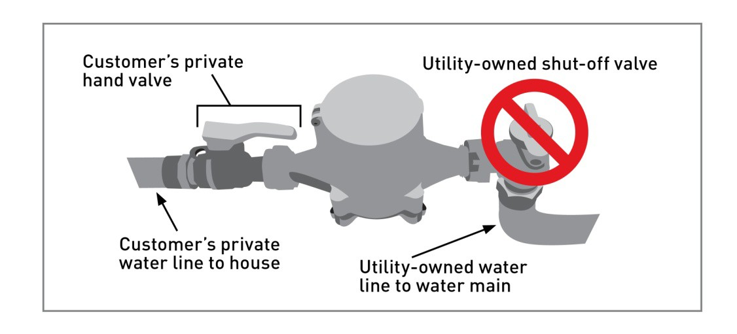
The City is offering rebates valuing up to $300.00 to residential water customers who purchase and have installed a customer-side shut-off valve on the customer’s water service line served by the City’s water system on or after October 5, 2019. Rebates prior to October 5, 2019 will still be processed up to $75.

Rebates are limited to one per residential account. In order to be processed, applications must include the original receipt(s) dated on or after July 1, 2016 for the purchase and installation of a customer-side shut-off valve.

How Do I Qualify?

Applicants must be Hendersonville Water and Sewer customers who are either property owners or the parties legally responsible for paying the water bill. Rebates are restricted to the purchase of and installation of an approved customer-side shut-off valve. For a list of approved shut-off valves see list below. Applicants must provide original receipt(s) dated on or after July 1, 2016 for the installation of the customer-side shut-off valve.

How Do I Apply?

1. Confirm that the customer-side shut-off valve you are purchasing and having installed is approved.

2. Purchase and have valve installed by a NC-licensed plumber. Complete the rebate application:

Online Application: http://www.hendersonvillenc.gov/rebate-programs

Applications can also be obtained at the City of Hendersonville Operations Center at 305 Williams St. or the Customer Service window at the Hendersonville City Hall, 160 6th Avenue East.

3. Mail, drop off or email a completed application with original dated receipt(s) attached to the address below:

City of Hendersonville
ATTN: Rebate
160 6th Avenue East
Hendersonville, NC 28792
Fax: 828-692-1510 Email: rebates@hvlnc.gov

4. All applications are subject to verification by City personnel. Upon approval, rebates will be issued on a first come, first serve basis. If approved, your account will receive a one-time credit equal to the rebate amount. You can confirm the availability of rebates by contacting Customer Service at (828) 697-3052.

For additional assistance or technical questions, please call (828) 697-3073.

Application Instructions:

1. Confirm your new shut-off valve is eligible:
§ Provide make, model and size, in inches.
§ Is the valve City approved?
§ Was the valve installed on or after July 1, 2016?
2. Acquire plumbing permit from appropriate permitting agency.
3. Purchase and install City-approved brass shut-off valve (See selection below); must be installed by a NC-licensed plumber to be eligible for rebate.
4. Mail in, email or drop off a completed application with original, dated itemized plumbing invoice or receipt to the address provided on the application form.
5. If approved, your account will be set up to receive a one-time credit of $75. We will contact you, in accordance with your preference listed above, to notify you of approval for the rebate. Please contact our billing office at (828) 697-3052 if this credit amount does not show on your bill.

Rebate Eligible Residential Shut-Off Valves
All customer side, private shut-off valves must be installed downstream of the meter, within two feet of the meter box (if possible) and must be one of the three non-lead shut-off valves manufactured by the following manufacturers:

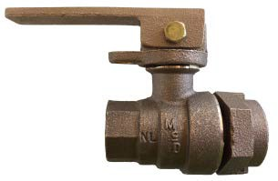
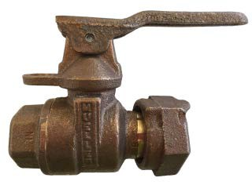
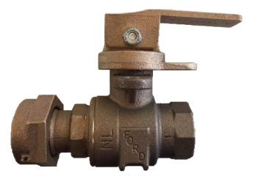
FORD MUELLER A.Y. MCDONALD

Each customer-side shut-off valve must be ¾ - 1-inch full port valves and must have a handle attached to allow the valve to be exercised by the customer without the need for tools.

